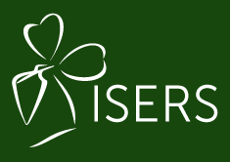
IRISH SHOULDER AND ELBOW REHABILITATION SOCIETY
ICSES Conference Bursary 2023
- This bursary is being offered by ISERS for a member to attend the 15th ICSES 2023 congress which is being held in Rome, Italy (Sept 5th to 8th 2023).
- A prize of €250 towards the cost of attending the conference will be awarded to the successful candidate.
- Applications will close on January 14t^{h}, 2023.
- All applications must be made by emailing this form to ISERS Chair: Karen.McCreesh@ul.ie

- How does attending the ICSES 2023 Congress relate to your current role and responsibilities or your personal development plan? (400 words max)

- What shoulder and elbow related CPD have you completed in the past two years? How will this event develop your current knowledge base? (200 words max)

- How will the information you gain from attending this event be disseminated to your professional colleagues and ISERS members? (200 words max)

